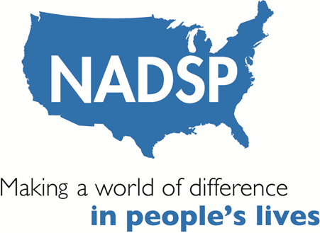

**National Alliance for Direct Support Professionals**

**Frontline Leadership Professional Development Plan**

Name: _____________________ Date: ______________________

*National Frontline Supervisor Competencies*

* Direct Support- The NADSP Competency Areas
* Health, Wellness and Safety
* Participant Support Plan Development, Monitoring and Assessment
* Facilitating Community Inclusion Across the Lifespan
* Promoting Professional Relations and Teamwork
* Staff Recruitment, Selection and Hiring
* Staff Supervision, Training and Development
* Service Management and Quality Assurance
* Advocacy and Public Relations
* Leadership, Professionalism and Self-Development
* Cultural Awareness and Responsiveness

A) Choose 3 areas from the above list of National Frontline Supervisor Competencies in which that you feel you exceed. List each one and then indicate what measures you will take in the next 6 months to share this expertise with your organization and what you will do to continue your proficiency.

1. ___________________________

b.

1. ____________________________

b.

1. _____________________________

b.

B) Choose 3 areas from the above list of National Frontline Supervisor Competencies in which that you feel you could improve your performance as a supervisor/leader. List each one and what you will do in the next 6 months to improve your performance in that area. Then indicate what you will specifically do to apply this learning in your organization.

1. ___________________________

b.

1. ____________________________

b.

1. _____________________________

b.

C) Choose one leadership book to read in the next 6 months. In the space below write your choice and commit to discuss the themes of the book with your supervisor, mentor and your specific team within 6 months.

Signature: _________________________________________________

Date: _________________________________

6-month follow-up review date: ______________________________

Your supervisor’s signature: ________________________________________